**Crypto Mutual Fund On Smart Contracts**

**Introduction**

The development of blockchain technology and the rapid growth of the Cryptocurrency market, new opportunities appear consistently in the field of Investment. The traditional economy changes its form, new values arise in the digital "world" and a significant role in these processes is played by decentralised technologies, in which Cryptocurrencies and digital tokens play a critical role.

**Abstract**

Crypto Mutual Funds are created from the investments of multiple investors that pool up their capital to the Crypto buy-and-hold funds. The Crypto assets shares will be buy based on tokens. In return, they are given a profit in the fund (usually in the form of “tokens”). The profit tokens can also be Exchange as a Ether .

**Tokenized Mutual Fund**

There are various types of funds that already invest in Crypto assets (Hedge Funds, Classic ETFs, Closed-End Funds, Venture Capital Funds). Independent and still a small segment of the market are tokenized funds. The key phenomena here is that investors acquire a share calculated by reference to the assets in the fund, implemented through tokenized smart contracts.

### **The Initial Coin Offering (ICO)**

### Starting a crypto fund is similar to offering the profit share to the investors in a company. Your Initial Public Offering (IPO) transaction forms the basis needed to attract investors towards your company. Therefore, you need to prepare a white paper agreement that discloses your project concept, duration, distribution of virtual tokens between you and the investors, and the 4goal of your ICO campaign. Tokens are produced on the Ethereum platform based on ERC-20 standard.

**Crypto Mutual Fund Flow**

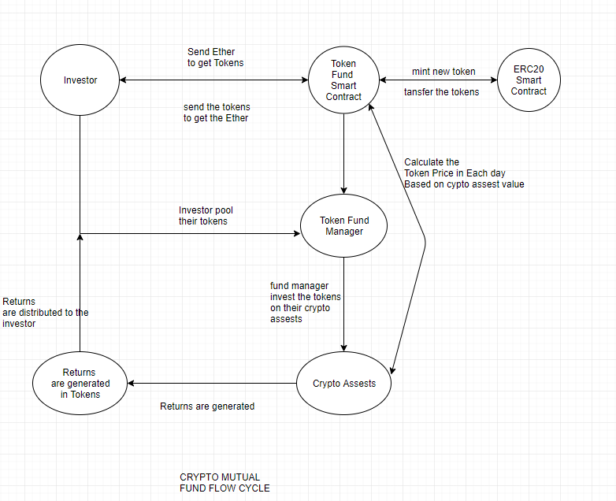

**Work Flow**

* First Investor have to buy the tokens so they to spend the specific Ether to buy the tokens using Token fund smart contract. The ERC20 token contract is linked with Token fund smart contract for continuously mint the tokens .
* The Investor have to invest the Tokens(Token fund) on Crypto Assets through the Token Fund Manager to buy a share. The Token fund manager have all the details about the Crypto Assets.
* The Fund Managers are responsible for pooling the tokens from the Investor and allocating proper shares for them.
* The returns are generated in the form of Tokens to the investor. The investor can use the profit tokens for reinvestment in the future (or) can exchange the profit tokens to ether.
* The Tokens value is get changes everyday based on the crypto assets rate.

**Technical Solutions**

**Components**

The technical solution for The Token Fund consists of three main elements:

* User-facing website
* Backend server for asset management
* Smart contracts on Ethereum blockchain

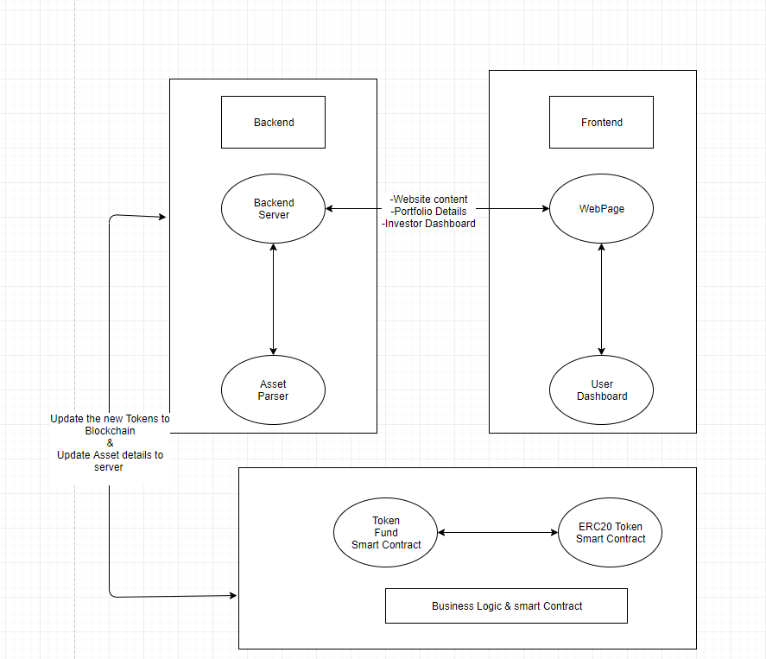

**Asset Management**

All the fund's assets are located at publicly accessible through Google Sheet. Every 12 hours asset parser component calculates current portfolio value and fund performance using API of popular blockchain explorers in order to receive balances of fund wallets and information from the token smart-contract. Fund performance and portfolio composition from the table are graphically displayed on the front page of The Token Fund. The client who wants to make investments and purchase TKN must undergo the KYC procedure ("know your customer"), for which identification documents are needed. The KYC procedure is carried out through the website interface.

In the dashboard an investor is able to create a wallet and back up the keys for it. An address provided by an investor or newly generated one is used by the service to issue new tokens.

**Backend Service**

Backend service is responsible for storing wallet addresses for Investors and for interacting with Ethereum Smart Contract. It takes current token supply from TKN contract and calculates last token price based on the fund portfolio asset value. After that, it acts as a company by publishing the latest price of the token on The Token Fund contract. The backend is also responsible for initialising new token issuance once it gets investment in Ethereum through the dashboard.

**Smart Contracts on Ethereum Blockchain**

The business logic of The Token Fund is controlled by two smart contracts on the Ethereum blockchain: one is a token that stores the balances of investors in the fund (ERC20-TKN contract), and another is responsible for issuing new tokens in exchange for invested money (The Token Fund contract). TKN contract is based on the ERC20 standard token contract with an extra function that allows new token emission. This function is only accessible by The Token Fund contract.

**Investment Flow**

A regular way of investing requires sending ether to the personal investment address available in the dashboard. After receiving an investment, the backend triggers the function on The Token Fund contract that calculates the number of tokens the investor should be distributed based on the current price of the token. After that, the backend service executes issuance function on The Token Fund contract to mint new tokens for a new investor.

**Advantages:**

* Ethereum smart contracts enable a very transparent and secure way of reward-sharing among the token holders.
* Investing in a crypto fund is that the Cryptocurrency is going to be the Currency of the future.
* Investing crypto funds to become safe to build your assets. Because mining is more complication in mining algorithms.
* Crypto funds provides higher profit, because Cryptocurrency value changes day by day.